**Document 04 – Sprint 2 Report**

CS 4321 – Summer 2022

Contents

1 Completed User Stories 1

2 Buggy User Stories 1

3 Incomplete User Stories 1

4 Class Diagram 2

5 System Tests 2

6 Video Demo 2

Appendix 1 Grading Criteria 3

# Completed User Stories

| **Deliverable**  List the User Stories (including both sprints) that are complete, tested, and correct. |
| --- |

| US Number | 1 – Add a Building |
| --- | --- |
| User Story | As a system admin, I want to add a building to the access management system so that I can add rooms and suites to that building. |
| Requirement | 3 |
| Notes | Code is complete |

| US Number | 2 – Add an Employee |
| --- | --- |
| User Story | As a manager, I want to add a new employee to the system so that I can grant them access to their work area |
| Requirement | 3 |
| Notes | Code is complete |

| US Number | 3 – Change Language |
| --- | --- |
| User Story | As a Dutch-speaking manager, I want to change the access management system’s language so that I can more comfortably use the system. |
| Requirement | 3 |
| Notes | Code is complete |

| US Number | 4 – Generate Access Attempt Report |
| --- | --- |
| User Story | As a security guard, I want to generate a report of access attempts so that I can find discrepancies and trespassers. |
| Requirement | 3 |
| Notes | Code is complete |

| US Number | 5 – Filter Access Attempt Log |
| --- | --- |
| User Story | As a manager, I want to filter the access attempt log in a way that only one employee is shown so that I can see if said employee came to work on time. |
| Requirement | 3 |
| Notes | Code is complete |

| US Number | 6 – Restrict Login Access |
| --- | --- |
| User Story | As an information security analyst, I want to restrict access to the access management system after three failed login attempts so that I can prevent unauthorized access. |
| Requirement | 3 |
| Notes | Code is complete |

# Buggy User Stories

| **Deliverable**  List the User Stories that are complete, tested, but have bugs. After the User Story, use square braces to briefly describe the symptoms and/or the suspected problem. For example: “As a human, I want to eat so that I won’t be hungry [Not all foods consumed are converted to calories correctly]” |
| --- |

| **Num** | **User Story** |
| --- | --- |
| 1 |  |
| 2 |  |
|  |  |

# Incomplete User Stories

| **Deliverable**  List the User Stories that are incomplete. These are User Stories where you have written some code, but are incomplete for any number of reasons. After the User Story, use square braces to briefly describe what works and/or what is missing. |
| --- |

| US Number | 1 – Adding and Removing area’s/objects |
| --- | --- |
| User Story | -As a system admin, I want to be able to add and remove different buildings, suites inside of buildings, and rooms inside the suits.  Add building code. |
| Requirement | 3 |
| Notes | … |

| US Number | 3 – Access Management. |
| --- | --- |
| User Story | -As a district supervisor of a company with multiple buildings such has our warehouse, corporate, and store facilities in our district, I need to be able to manage our employee’s access to different buildings.  -As a store manager I need to be able to manage our employee’s access to different rooms.  -As a corporate facility IT tech, I need to be able to provide access or restrict access of non-IT personnel into our data suite. |
| Requirement | 3 |
| Notes | … |

| US Number | 4 – Simulation of employee attempting to  open accessible and inaccessible doors. |
| --- | --- |
| User Story | -As system admin I need to be able to make sure that the system is recording all access attempt and is restricting and allowing access to employees correctly by simulating employees with different restrictions trying to access all areas. |
| Requirement | 3 |
| Notes | …. |

| US Number | 5 – Logging of all access attempts |
| --- | --- |
| User Story | -As security I need the system to log all access attempts made by anyone so that I can track down any security threats. |
| Requirement | 3 |
| Notes | …. |

| US Number | 6 – Persistence |
| --- | --- |
| User Story | -As a manager I need the system to be able to save all information so that I only have to add or remove area’s and add or restrict access once. |
| Requirement | 3 |
| Notes | … |

| US Number | 7 – Successful generation of reports |
| --- | --- |
| User Story | As a manager I need the system to be able to generate reports with different parameters so that I can easily narrow down desired information. |
| Requirement | 3 |
| Notes | … |

# Class Diagram

| **Deliverable**  At the conclusion of this sprint, you should make a class diagram using StarUML. You can make multiple diagrams at different levels of granularity, or just break it up. Include a brief narrative. Your objective is to convey your design to me. The diagram(s) must be readable. Also include the digrams saved as image files in your docs folder on GitHub. |
| --- |

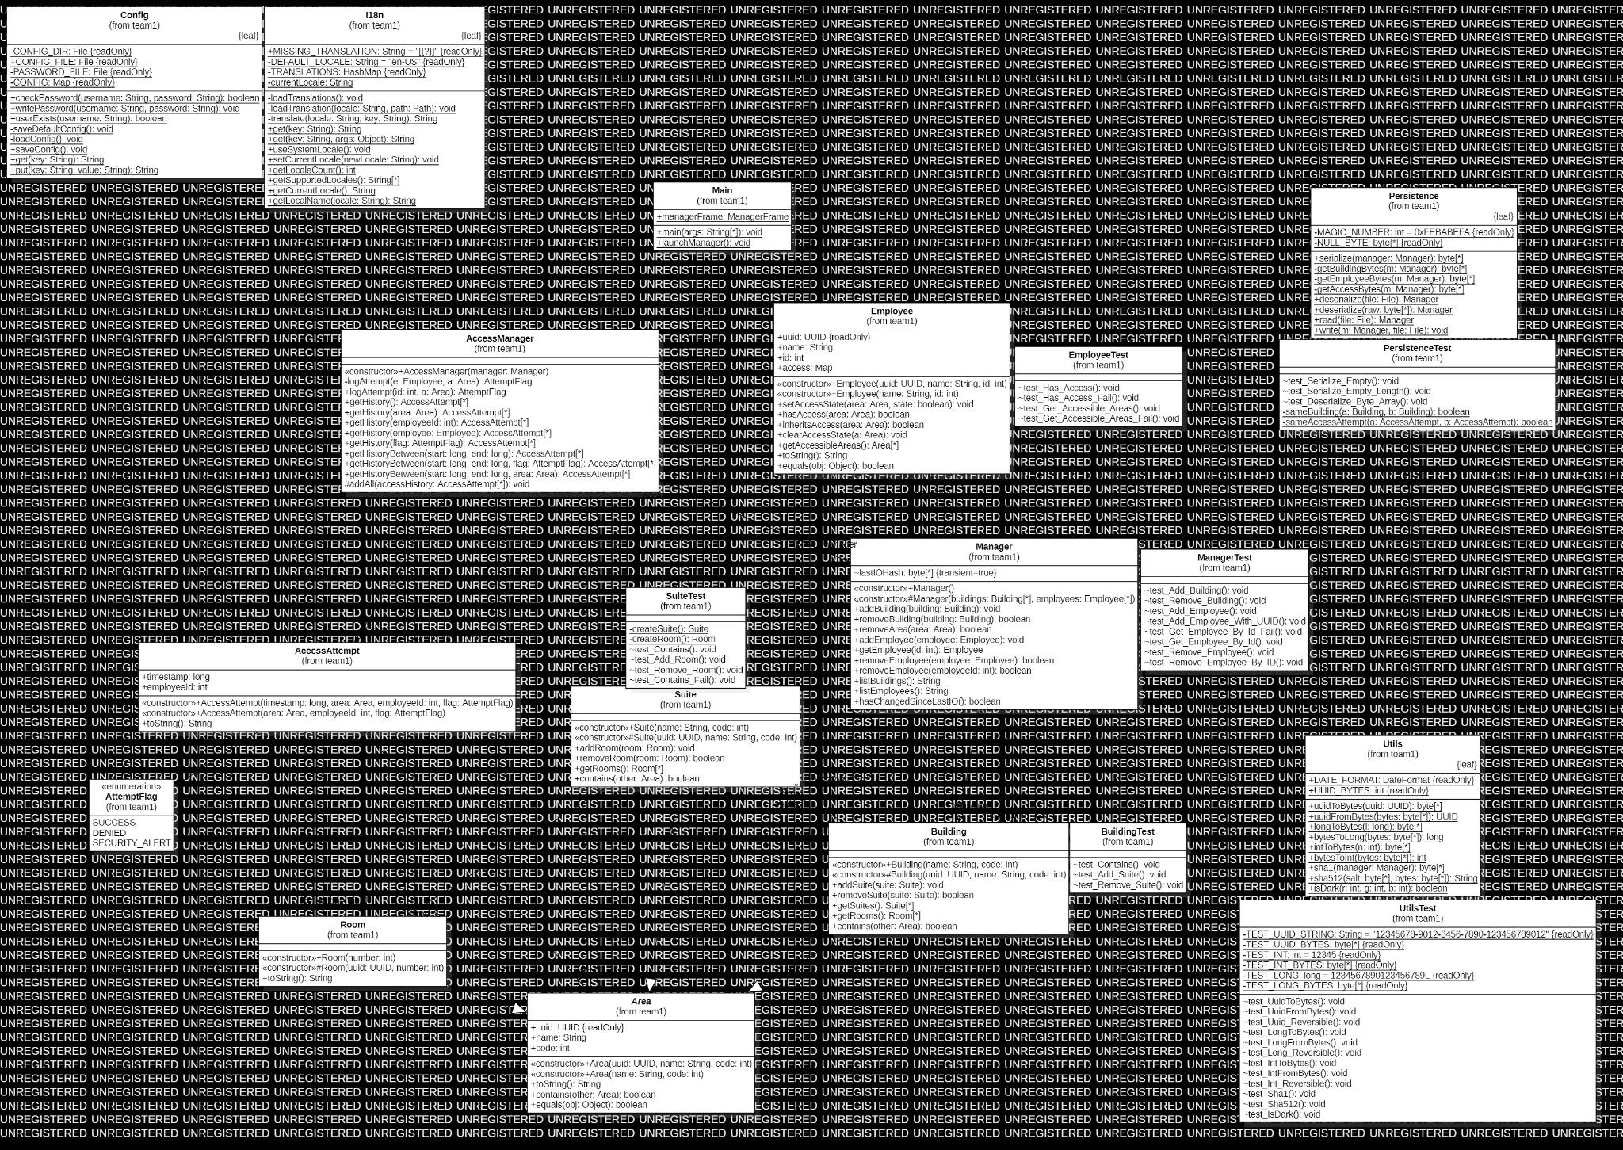

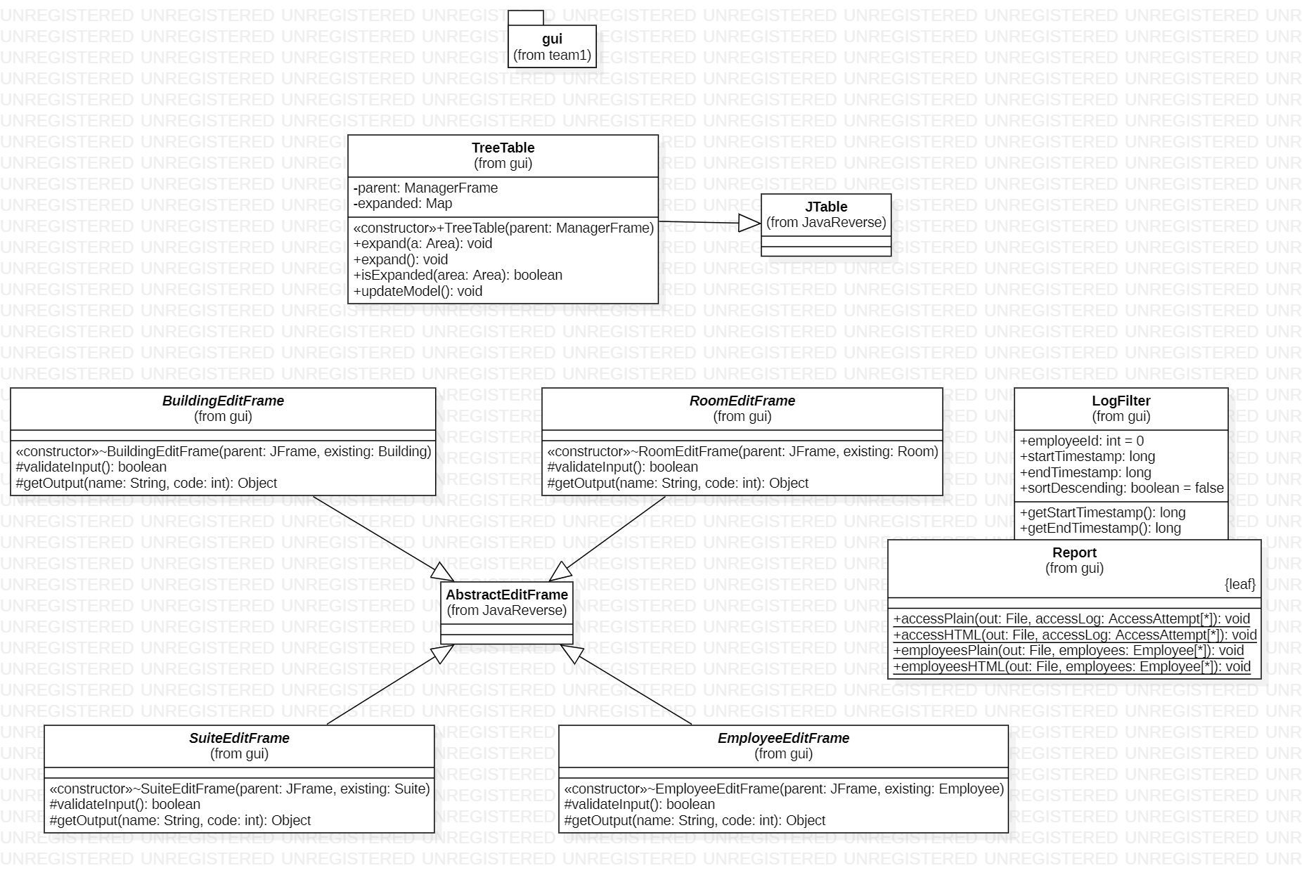

# System Tests

| **Deliverable**  You probably will have multiple System Tests for each user story. |
| --- |

| Test Number | 1 |
| --- | --- |
| US Number | 1 |
| Description | A building named “Shipping” will be added with no suites or rooms. Using the access management system, the building will be removed. Shipping should be removed without issue. |
| Status | Success |

| Test Number | 2 |
| --- | --- |
| US Number | 1 |
| Description | A building named “Warehouse” will be added with two suites and no rooms. Using the access management system, the building will be removed. When Warehouse is deleted, its two suites should automatically delete, since a suite cannot exist outside of a building. |
| Status | Success |

| Test Number | 3 |
| --- | --- |
| US Number | 1 |
| Description | A building named “Shipping” will be added with three rooms and no suites. Using the access management system, the building will be removed. The system should give an error message, saying that a room cannot be added without a suite. |
| Status | Success |

| Test Number | 4 |
| --- | --- |
| US Number | 2 |
| Description | An employee named Laura with an ID of 4050 will be added to the access management system. |
| Status | Success |

| Test Number | 5 |
| --- | --- |
| US Number | 2 |
| Description | An employee named Laura with an ID of 4050 will be granted access to the Warehouse building, which doesn’t exist. The system should give an error message saying that the building doesn’t exist. |
| Status | Success |

| Test Number | 6 |
| --- | --- |
| US Number | 2 |
| Description | An employee named Laura will be granted access to room 8001 on the fourth floor of the Processing building |
| Status | Success |

| Test Number | 7 |
| --- | --- |
| US Number | 3 |
| Description | By clicking Settings -> Language -> Deutsch in the upper right corner, the access management system will be displayed in Dutch instead of English. |
| Status | Success |

| Test Number | 8 |
| --- | --- |
| US Number | 4 |
| Description | By clicking Reports -> Generate Access History Report -> Plain Text, the access management system will generate a report of all access attempts from all buildings, suites, and rooms. The report will show who attempted to access, the time of the attempt, and whether or not access was granted. |
| Status | Success |

| Test Number | 9 |
| --- | --- |
| US Number | 5 |
| Description | The manager will use the “Filter Log” button to find the time at which an employee named Laura accessed the Main Building. Laura’s access attempts will be singled out by using her ID. From there, the attempts can be narrowed further to any attempts made on 7/20/2022. The manager will then be able to see if Laura made it to work on time on 7/20/2022. |
| Status | Success |

| Test Number | 10 |
| --- | --- |
| US Number | 6 |
| Description | At the login screen, a fake username and password will be used to try and log in three times. After the third failed attempt, the system will time out for an hour. |
| Status | Success |

| Test Number | 11 |
| --- | --- |
| US Number | 6 |
| Description | After getting locked out of the access management system for one hour, a valid username and password will be used to log in to the system during the lockout. Since an hour has not yet passed, the user will remain unable to log in, even with the correct credentials. |
| Status | Failure |

| Test Number | 12 |
| --- | --- |
| US Number | 6 |
| Description | After getting locked out of the access management system for one hour, the system will be closed and reopened in an attempt to bypass the lockout. The lockdown should remain in effect. |
| Status | Success |

| Test Number | 13 |
| --- | --- |
| US Number | 6 |
| Description | After getting locked out of the access management system for one hour, the system will be closed and the computer’s clock will be manually advanced by one hour. The lockout will be over when the system is accessed again. |
| Status | Success |

| Test Number | 14 |
| --- | --- |
| US Number | 6 |
| Description | After getting locked out of the access management system for one hour, the system will be closed and the computer’s clock will be manually advanced by one hour. The system will then be reopened and logged into. After closing the system again, the computer’s clock will be set to its original configuration. The system should resume its lockdown. |
| Status | Success |

# Video Demo

| **Deliverable**  Create a video that demo’s your User Stories and provide the link(s) here. **Preferably, post your video(s) on Youtube**. You can make a single video, or, if needed, several. For each User Story, state the number of the User Story, and then state the User Story itself, then demonstrate it with your software. |
| --- |

| Video Link(s) |  |
| --- | --- |

Appendix

1. **Grading Criteria**

The final project will be evaluated on these criteria:

| **Sprint 2 Report** |
| --- |
| User Stories |
| Class diagram |
| System Test Descriptions |
| Video |
| **Code** |
| Number of User Stories Implemented |
| Unit Tests |
| Quality of design |
| Use of MVC |
| Wow factor of GUI |
| **GitHub** |
| Use of GitHub Project & Issues |
| Use of Pull Requests |
| **Individual Effort** |
| Hours |
| Code Review via Pull Requests |
| Contributions to code base |